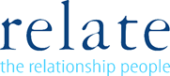

Relate Nottinghamshire Client Fees

Relate Nottinghamshire | Lower limit annual income | Upper limit annual income | Fees Charged per session
Band A | £80,000+ |  | £100
Band B | £50,000 | £79,999 | £80
Band C | £35,000 | £49,999 | £70
Band D | £20,000 | £34,999 | £45
Band E | £10,000 | £19,999 | £35
Band F | 0 | £9,999 | £25

