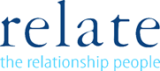

Relate Nottinghamshire’s Client Fees

Relate Nottinghamshire | Lower limit annual income | Upper limit annual income | Fees Charged per session
Band A | £0 | £10,000 | £25
Band B | £10,001 | £19,000 | £35
Band C | £20,000 | £29,000 | £45
Band D | £30,000 | £40,000 | £65
Band E | £41,000 | £74,000 | £70
Band F | £75,000 | Above | £80

