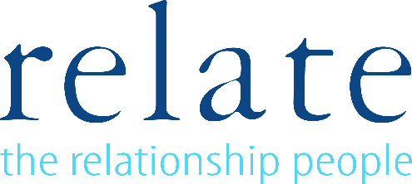
Compulsive Sexual Behaviours Disorder group (often referred to as sex or porn addiction)

Relate Nottinghamshire have been running these groups very successfully for the past 8 years.
The next group is TBC but will take place on a Friday for 14 weeks between 3-5pm – there is also a weekend – all day Saturday and Sunday halfway through the course, there is also a “follow-up” day 3 months after the course finishes. In total there is up to 46 hours of participation. The course costs are £1800 per person, and this can be paid for in several ways including by direct debit over a 10-month period.
The course is facilitated by two trained, qualified, and accredited therapists and is available for up to 8 men to attend. Participants can attend from anywhere but do need to be able to get to the centre of Nottingham for the meetings. All the men are assessed for suitability to attend the group by one of the therapists running the group.
This Recovery Group aims to help men develop strategies to stop the behaviours associated with the compulsion (addiction). It is not intended to replace individual and/or couple therapy or Twelve Step programmes, but rather augment them.

Group work provides a different but very effective way to access support for any form of compulsive behaviour or addiction. The course is not designed as a therapy group but is a course designed to support change through learning more about the effects of the behaviour, understanding personal triggers and developing alternative ways of coping without the reliance on porn or other sexual behaviours. It will mean sharing personal experiences and feelings which is part of the process that leads to change.

Phil a 35-year-old teacher wrote "The benefit of working as a group very quickly becomes apparent- everyone adds value and every week feels like it significantly enhances my self-control and understanding".

For an assessment to suitability or for further information please contact the centre on 01159584278 between 9am-5pm Monday-Friday or email: info@relate-nottingham.org.uk

Company Limited by Guarantee, Registered Company No. 04178259, Registered Charity No. 1086299

